Clinton County Health Department
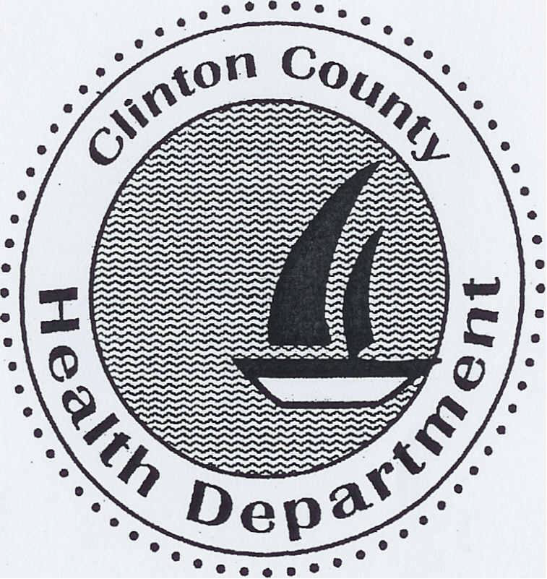

Annual
Report
  - FY 2022
It is the mission of the Clinton County Health Department to protect and enhance the quality of life of the people we serve.

To Our Citizens
On behalf of the Clinton County Board of Health and our staff, I am pleased to present you with the 2022 annual report of operations. 2022 has been a transitioning year for our county. COVID-19 has continued to be a major focus of our staff and administration. The health department has continued to hold vaccination clinics. We have also had our testing site open the entire year so our community can continue to receive the testing that it needs. We have made changes to our daily operations to help better serve the community with our many services that are non-covid related. While COVID has continued to be a major priority for us, we want to make sure that none of our services suffer due to this pandemic.
The Clinton County Health Department ended Fiscal Year 2022 with a cash balance of $1,193,602.65. We are excited about the news of building of our new facility so we can better serve the citizens of Clinton County. The Board of Health and I look forward to exploring new avenues to add services for the citizens of Clinton County.

Clinton County Board of Health
Brian Klostermann, MD……………………………….……………………………………………………….…………………………………Chairperson
Terri Linton, SLP...……………………………………………………………………...………………………….……..………….…………………Secretary
Paulette Evans, RN……………………………………………………………………..……………………………………………………Vice Chairperson
Robert Hyten, III, DMD…………………………….……………………..……………………………………..……………………………………Treasurer
Dr. Deanna Ducomb……………………………………………………….……………………………………………..……………………Board Member
Traci Foster, NP…………………………………………….……………………………………………..…………………………..Board Member
Kimberly Hugo, RN…………………………………………………………………………………………………..……………….………..Board Member
Stacy Albers, RN………..……………………………………………………………………………………………………………………….Board Member
Mike Kuhl………………………………………………………………………………………….….…………………… Voting County Board Member
Holly Clark………………………………………………………………………………....…….…………………Non-Voting County Board Member

Clinton County Health Department Staff
Chris Leidel LEHP……….………………………………………….……………………………………………………..…………..…….Administrator
Marian Voss……………………………………………………………….……..………………………………...……………....Assistant Administrator
Hannah Wheelan…………….……………………………………………………..…………………..……………………….…Emergency Response
Nadine Kuhn………………………………………………………………………………………….……………………Emergency Preparedness
Tamra Dugger RN…………………………………..……………….…………………………….……….………………….…Public Health Nurse
Sharon Lampe RN…………………………………………..………….…………………………………….……………..……….Public Health Nurse
Kris Tebbe………………………………………………..…………………….……………………………………..……………………………………....Deputy
Ellie Jansen………………………………………………………………………………………………………………………………………………Deputy
Holly Timmermann LEHP………………………………………………………….……….…..Licensed Environmental Health Practitioner
Michelle Hawes RN………………………………………………………………………………………………………………………….……WIC/FCM
Jennifer Steinkamp RN…………………………………………………………………………………………………………………………….WIC/FCM

Clinic Programs
Adhering to our mission, the Clinton County Health Department strives to protect and enhance the quality of life of the people we serve. Programming is designed to address the health needs of the community based on a comprehensive community health assessment called the IPLAN. Based on the findings of the 2021 IPLAN the priorities for our county are Mental and Behavioral Health, Healthy Behaviors, and Food Insecurity.

Services
- Immunizations (Adult/Child/Infant)
- Communicable Disease Control
- TB Screening and Treatment
- Venipunctures for Laboratory Analysis
- Free Blood Pressure Screening
- Allergy and Medical Injections
- Women, Infant, and Children (WIC) Health and Nutrition Program
- Family Case Management/Referral Services
- Developmental Screenings
- High Risk Infant Follow-up/Adverse Pregnancy Outcome Reporting System (APORS)
- Health Works
- Lead Screening/Follow-up
- Breastfeeding Support
- DNA Testing
- Drug Screening
Communicable disease/immunization/other SERVICE OVERVIEW 2022
COMMUNICABLE DISEASE INVESTIGATION/CONTROL
BRUCELLOSIS…………………………………………………………….……..1
CAMPYLOBACTERIOSIS…………………………………………….………1
CHLAMYDIA...........................................................................32
CRYPTOSPORIDIOSIS…………………………………..……………….……0
ECOLI 0157:H7………………………………….……….…………….….……0
GONORRHEA..........................................................................5
Haemophilus Influenza……………………………………………………..0
HEPATITIS A……………………………………………………………………….2
HEPATITIS B.............................................................................2
HEPATITIS C………....................................................................10
INFLUENZA with ICU Hospitalization……………………………….0
INVASIVE STREP A…………………………………………………………..0
LEGIONNAIRES DISEASE………………………………………….……….0
LYME DISEASE…………………………………………………………..….…2
Rabies…….…………………………………………………….….………….…3
ROCKY MOUNTAIN SPOTTED FEVER………………………………..0
SALMONELLA..........................................................................0
SHIGELLOSIS………………………………………………………………..…0
SYPHILIS……………………………………………………………..………....1
TYPHUS…………………………………………………………………..……..2
VARICELLA…………………………………………………………………..….6
YERSINIOSIS……………………………….…………….…………………….0
STD Follow-up………………………………………………………………80

IMMUNIZATIONS
DEPO PROVERA…………………………………………………………………14
DTAP…………………………………………………………………………..………0
GARDICIL................................................................................11
HALDOL…………………………………………………………………………12
HEPATITIS A............................................................................2
HEPATITIS B............................................................................8
HIB..........................................................................................20
INFLUENZA……………………………………………………………………….386
MENACTRA.............................................................................35
MMR......................................................................................5
PEDIARIX…………………………………………………………………….........22
PENTACEL……………………………………………………………….…….....….0
PREVNAR ...............................................................................25
PROQUAD…………………………………………………………..……………..17
PNEUMONIA……………………………………………………………………….2
ROTARIX/KINRIX…………………………………………………………..……..14
TDAP.......................................................................................66
TESTOSTERONE………………………………………………………………….8
TYPHOID……………………………………………………………………………..2
VARICELLA................................................................................6
VITAMIN B12……………………………………………………………………...2
OTHER MEDICAL SHOTS...........................................................0
TB SKIN TESTS………………………………………..………….………….….211

OTHER SERVICES
BLOOD PRESSURE SCREEN.....................................................13
DNA TEST…………………………………………………………………………...2
DRUG SCREEN………………………………………………………………………2
LEAD TESTS ………….................................................................18
ALLERGY INJECTIONS..............................................................12
BLOOD LAB TESTS...............................................................1262

Maternal and child health overview 2022
WIC is a supplemental food nutrition program, counseling and education services for pregnant and nursing women and children up to age 5, who show nutritional and financial need.

Number of Clients..............................................................309*
Number of Food Instruments issued: We no longer issue Food Instruments to our clients. Each family that is new to WIC receives a WIC EBT card at their initial certification appointment.
Certifications………................................................................370
Follow-up…………………………………………………………….…………...194
Internet Education…………………………………….……………..…..….447
Lead Screening: We have not performed Lead Screenings on our youth participants this past year due to the COVID19 pandemic restrictions set forth by the State. We are continuing over the phone appointments through the end of July 2022 per USDA State guidelines.

FAMILY CASE MANAGEMENT
Case Management services, including home visits, are available to pregnant women, infants and children who meet financial and age eligibility. Family Case Management staff also provides services for high risk infants through the Illinois Perinatal Tracking program entitled Adverse Pregnancy Outcome Reporting System (APORS) and Medical Case Management for Department of Children and Family Services (DCFS) wards.

Clients.................................................................................150*
DCFS Clients..........................................................................23
APORS Clients........................................................................16
*Monthly Average

Environmental health programs OVERVIEW 2022
ENVIRONMENTAL HEALTH PROGRAMS
The Clinton County Health Department inspects all retail food establishments, private sewage systems and private water wells within Clinton County.
Food Sanitation Program:
Number of Food Service Establishments 234
Number of inspections/Follow-ups 308
Potable Water Program:
State Water Well Permit
Well Permits Issued 10
Closed Loop 16
Well Inspections 24
Total Well Inspections 34 1
Private Sewage Program: County Sewage Permits
Permits Issued 59
Inspections/Consultations 47
Complaints 9
Subdivision Plat Reviews 11
Nuisance/Solid Waste Program:
Complaints Investigated 17
Inspections 11
West Nile Virus Surveillance
Samples 133
Viable Samples Tested 133
Positive Mosquito Tests 17
Positive Bird Tests 0
Reported Human Cases 0
Public Health emergency preparedness 2022

Making sure the public is safe and ready for an emergency is a priority of the Clinton County Health Department. The Clinton County Health Department has an Emergency Preparedness and Response Program and oversees the Emergency Public Health Preparedness Activities, Cities Readiness Initiative and the Medical Reserve Corp. The Program works closely with community partners to address and prepare for emergencies and potential disasters. This has allowed our department to head the Contact Tracing and Mass Vaccinations efforts of Clinton County.

financial OVERVIEW 2022
Revenues | $1,151,328
Taxes | $187,797 | 16%
Grants | $791,213 | 69%
Medicaid | $2,149 | 1%
Miscellaneous | $170,169 | 15%

Expenditures | $1,028,546
Salaries | $667,680 | 65%
Contracts | $3,952 | 1%
Commodities | $91,285 | 9%
Grants | $265,629 | 25%

(not audited)

